**MID TERM ONE ASSESSMENTS 2024**

**LEARNING AREA: LITERACY ONE**

**CLASS : PRIMARY ONE**

**PUPIL’S NAME :**

Each correct answer carries 2 marks

**1.** Name these things found at home.

|  |  |  |  |
| --- | --- | --- | --- |
|  |  |  |  |
|  |  |  |  |

**2.** Write the name of your school.

_______________________________________________________

**3**. Who teaches children at school?

_______________________________________________________

**4.** Circle people found at school.

teacher, mother, cook, Anna, bursar.

**5.** Write your name.

_________________________________________________________

6. Give any four animals kept at home.

i) ___________________________ ii) ___________________________

iii) ___________________________ iv) _______________________

**7.** Match correctly.

Teacher Library

Cook Dormitory

Librarian Classroom

Matron Kitchen

**8.** Draw these school symbols.

|  |  |
| --- | --- |
|  |  |
| School uniform | School flag |

9. Give any four things found at school.

i) _____________________ iii) _________________________

ii) ____________________ iv) __________________________

10. Circle activities done at school.

writing , digging , drawing , stealing , reading.

11. Draw these things we see on the way to school

|  |  |  |  |
| --- | --- | --- | --- |
|  |  |  |  |
| tree | car | house | people |

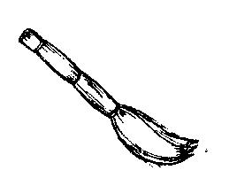**12.** Match correctly

for writing in

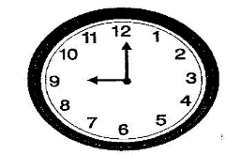

for sitting on

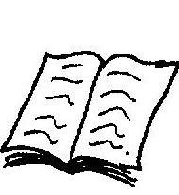

for sweeping

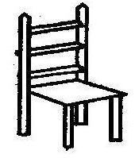

for showing time

**13.** Why do you go to school?

______________________________________________________

**14.** Fill in the missing letters.

f ___ ther m ___ ther s ___ ster b __ by

**15.** Fill in a correct word to complete the story.

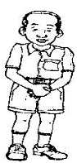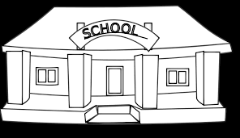

John is a good ___________. He goes to ________



every day to learn. He goes with a _____________, a

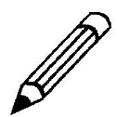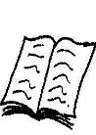

_________ and a __________. At school, John sits on the

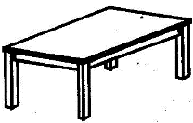

__________ and writes from the ______________.

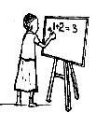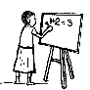

All ______________ love him because he does good

work at school.

**16.** A cow gives us ________________ and ______________.